Q.1 A student has gotten the following grades on his tests: 87, 95, 76, and 88. He wants an 85 or better overall. What is the minimum grade he must get on the last test in order to achieve that average?

Q.2 Find the mean of the following distribution.
(a) The age of 20 boys in a locality is given below.
Age in Years | 12 | 10 | 15 | 14 | 8
Number of Boys | 5 | 3 | 2 | 6 | 4
(b) Marks obtained by 40 students in an exam are given below.
Marks | 25 | 30 | 15 | 20 | 24
Number of Students | 8 | 12 | 10 | 6 | 4

Q.3 The average salary of male employees in a firm was Rs.520 And that of females was Rs.420. The mean salary of all the employees was Rs.500. Find the percentage of male and female employees.

Q.4 Obtain the median for the following frequency distribution:
X : 1 2 3 4 5 6 7 8 9
f : 8 10 11 16 20 25 15 9 6

Q.5 In 2000 the mean weight of 10year olds was found to be and the standard deviation was 3.5. In 2010 the mean weight of 10year olds was found to be and the standard deviation was 2.1. Which of these statements is a fair comparison?
- In 2000, the weight of 10year olds was less consistent than in 2010.
- In 2010, 10year olds weighed less on average than in 2000.
- In 2010, the weight of 10year olds was less consistent than in 2000.
Q.7 If we want an average distance to the mean, why can't we just add up all the differences to the mean and take the average?

Q.8 Below is the table showing the values of the results for two companies A, and B.
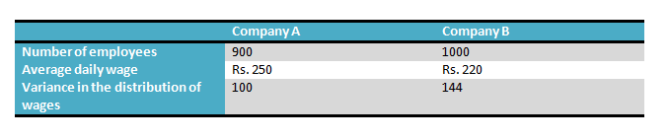Which of the company has a larger wage bill?
Q.9 Why do we use the square function? What are its implications?
Q.10 Why do we work on standard deviation and not the variance?

